
A guide to Quality Adjusted Life Years (QALYs)

Medicines can prolong life, improve the quality of life, or both. Everyone wants to have the most effective medicines but unfortunately budgets are not unlimited. This means difficult choices have to be made about what treatments can be made routinely available. SMC’s work lies at the heart of this.

To help us determine whether or not a medicine offers good value for money for NHSScotland, we use an economic tool called the Quality Adjusted Life Year (QALY). The QALY is a widely and helps those assessing healthcare to take a consistent approach to comparing the value of different medicines.

Although the QALY is a key part of our decision making process, we also take other important factors into account. These include:

- the needs of patients
- the views of doctors
- the number of people affected by the condition
- what other treatments are available for that condition

A QALY takes into account how a treatment affects a patient’s

- quantity of life (how long you live for)
and
- quality of life (the quality of your remaining years of life).

The QALY combines both these factors into a single measure that puts a figure on the health benefits for any medical treatment. QALYs provide a benchmark that we can use to measure and compare the benefits that each medicine is likely to offer.

How to work out a QALY

Scenario 1

Imagine a person is fully healthy but has a risk of sudden death. There is a new medicine that will make him live for exactly 12 months in perfect health. If he takes this medicine he will gain a year of life at 100% of normal quality. This would be a QALY of 1.

Health experts widely accept the following:
- A year of perfect health has a QALY of 1.
- A year of less than perfect health has a QALY between 0 and 1.
- Death has a QALY of 0.

Scenario 2

Again imagine a person who is fully healthy but has a risk of sudden death. There is a new medicine that will give him two years of extra life but he will not be restored to full health and his quality of life will be only 75% of that experienced by a fully healthy person. If the person takes this medicine he will gain 1.5 QALYs (2 years x 0.75 = 1.5) compared to being given no treatment at all.

Scenario 3

Imagine a person has a chronic condition that is reducing his quality of life to 50% of that experienced by a fully healthy person. He is expected to live five years. There is a new medicine that will help this person’s symptoms and improve his quality of life to 75%. However, it will not affect the time he is expected to live. Overall, this person will gain 1.25 QALYs (5 years x 0.25) compared to if he was given no treatment at all.

How to work out the cost per QALY

The QALY itself cannot tell you if a treatment provides value for money. Instead, we combine the QALY for a new medicine with the cost of the new medicine. This produces a ratio called the cost per QALY.

The cost per QALY shows how many extra quality adjusted life years the new medicine gives and how much extra it costs compared with the current treatment. This then allows SMC to judge if the new medicine is good value for money.

For example, a person has a serious life-threatening condition and is currently receiving medicine X. If he continues to receive medicine X he will live for 10 years and his quality of life will be on average, 50% of normal (0.5). If he receives a new medicine, medicine Y, for the same condition, he will live for 12 years and his quality of life will be, on average, 70% of normal (0.7).

The new medicine, medicine Y, is compared with medicine X in terms of QALYs gained as follows:

- medicine X: QALY = 5 (10 years x 0.5)
- medicine Y: QALY = 8.4 (12 years x 0.7)

Therefore, medicine Y results in 3.4 additional QALYs when compared with medicine X.

Medicine Y costs £10,000 more than medicine X. The difference in treatment cost is divided by the number of QALYs gained. This provides the cost per QALY i.e. £10,000 / 3.4 = £2,941. Therefore, medicine Y would cost £2,941 per QALY.

This is shown diagrammatically in the figure below. The extra health benefits (measured as QALYs gained) are represented by the summation of areas A and B. Area A equates to the gains in terms of improved quality of life with medicine Y compared to medicine X, whereas area B represents the gains in life extension from medicine Y keeping the patient alive longer than medicine X,

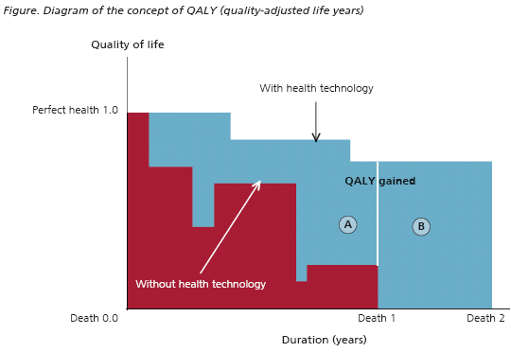

How does SMC use QALYs?

In assessing clinical and cost-effectiveness, comparisons can be made between costs per QALY for different medicines. Some medicines may have a low cost per QALY and we would say these offer good value for money. Medicines with a high cost per QALY would not be considered good value for money. In the UK, a cost per QALY of under £20,000 is generally considered acceptable value for money by health technology assessment organisations. For a medicine with a cost per QALY between £20,000 and £30,000 SMC might accept this if the medicine gives significant benefits over existing treatments. In addition, SMC has a number of factors that can be applied to medicines with a cost per QALY above £30,000 to allow their acceptance in some cases. SMC calls these modifiers. In addition, SMC has increased flexibility to accept a higher cost per QALY for medicines eligible for review under SMC’s Patient and Clinician Engagement (PACE) process.

In summary, the cost per QALY for a medicine is helpful in understanding the value for money that the medicine offers. Although QALYs are not a perfect tool they help us to compare the benefits of medicines fairly and are essential to SMC’s new medicines assessment process.
It is important to note that QALYs provide the basis for discussion about individual medicines by the Scottish Medicines Consortium, the QALY alone does not determine the decision reached.

Further reading

What is cost-utility analysis?
http://www.bandolier.org.uk/painres/download/whatis/What_is_cost-util.pdf

British Medical Journal economics notes series available from www.bmj.com Education and debate: Economics notes: Economic evaluation: an introduction by James Raftery BMJ 1998;316:1013-1014 (Published 28 March 1998)

